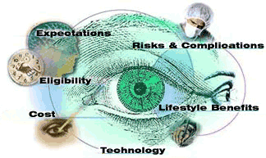
- Expectations reviews information needed to help establish realistic post-operative expectations.
- Eligibility reviews conditions that doctors evaluate to determine a patient's eligibility for the procedure.
- Lifestyle Benefits provides some reasons patients seek refractive surgery · Risks & Complications discusses this issue in depth and provides statistical data regarding occurrence rates.
- Risks & Complications discusses this issue in depth and provides statistical data regarding occurrence rates.
- Cost provides general information for patients considering the surgery and questions to ask regarding services offered.
- Technology provides a general overview of the excimer lasers used in the LASIK procedure.

